**The verb "can"**

**Use**

Can is a verb that is very often used in the English language. We use it when we

express that someone is able to do something: He can speak Spanish.;

express that something is possible: The kids can stay at our place after school.;

**Rules**

Can has only one form. It does not change with he, she, it:

I can

You can

He, She, It can

We can

You can

They can

**Positive structure**

Subject + can +verb in base form + complem.

Examples

She can swim

They can go

We can meet you there

**Negative structure**

Subject + can+ not +verb in base form + complem.

The "negative form" of can is can't or cannot: You cannot go to that party! She can't speak English. I can't call you because my phone is out of order.

She can not swim

They can´t go

We can´t meet you there

**Yes/ no Question**

Can + subject +verb in base form + complem.?

Can she swim? Yes, she can / No, she can´t

Can they go? Yes. They can / no, they can´t

Can we meet you there? Yes, we can / No, we can´t

**Examples**

* You **can** speak English.
* She **can** visit my mother.
* You **can**not speak in class.
* **can** he read a great book?
* She **can** write ten sentences.
* They **can** fly in an airplane.
* She **can** be a fabulous doctor in the future.
* **Can** she drive a car?

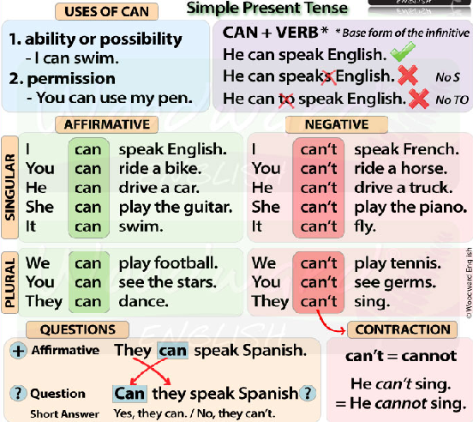

Videos of Can

<https://www.youtube.com/watch?v=EAFQ9Pj_hSM>

<https://www.youtube.com/watch?v=4HZsOaCea5M>